Music Streaming over Bluetooth

tasmeen kaur kathuria 1001150823

T.Venkata swathi avyaktha 1001267162

Nabilahmed Patel 1001234817

Archan Joshi 1001267688

Sai Aravind Palagummi Venkata NAga 1001242023

TABLE OF CONTENTS

1. Introduction 4

2. Objectives 5

2.1 Business Objectives 5

2.2 System Objectives 5

3 Risks 6

3.1 Project Risks 6

4. Assumptions and Constraints 7

4.1 Assumptions 7

4.2 Constraints 7

5. Conclusion and Recommendations 8

6. Instructions of Execution 9

7. Snapshots: 10

11

8. Appendices 17

# 1. Introduction

The objective of this project is to develop an android application for a Bluetooth enabled device. We are using 5 devices in which the device in between the sender and receiver acts as a relay. The Sender and the receiver connect and communicate with each other using the 2nd device that plays the role of a relay. This application has two tables, an owner table and a routing table. The device searches both the tables for the song. Firstly, when you select the name of the song that you want to play, it’ll start fetching that particular song from the sender device and then when you hit the play button it’ll start streaming the song on the device. Implement an algorithm that selects the shortest path available in between the devices based on the weights.

1.1 Procedure

1. Bluetooth should be turned on in all the phones.
2. Search the song from the owner table.
3. If the song is present in the owner’s device, then it can play the song.
4. If the song isn’t present in the owner’s device, search the owner table to identify the owner.
5. Search the routing table to identify the relay in between.
6. Request the song using the owner table.
7. On the receiver side check the header of the packet, if the request is for device B, then send song to A.
8. If the request is for device C, forward the request from Device B to device C and similarly for the devices D and E.
9. Implement a shortest path algorithm so that the device selects the path that has the least weight and streams from it.
10. The weights are randomly generated.

# 2. Objectives

## 2.1 Business Objectives

The following is the list of business objectives:

**Objective 1**: Device A contains the song xxx. If Device A wants to play the song xxx, it can directly play the song from itself (Device A).

**Objective 2**: Device B wants to play the song xxx but the owner of the song xxx is Device A. So Device B checks the routing table and has to connect the phone with device A via Bluetooth and then it can stream and play the song.

**Objective 3**: Device C wants to play the song xxx. So it checks the owner table and finds that the owner of the song xxx is Device A and then Device C checks the routing table. Device C connects to Device A via Device B (RELAY) through Bluetooth and streams the song from Device A.

**Objective 4**: Similarly establish the socket connections with devices D and E as well and make sure that the concept of relay is working amongst all the devices.

**Objective 5**: Consider A wants to stream a song from E. Implement an algorithm that selects the shortest path based on the randomly generated weights in the graph.

## 2.2 System Objectives

The following is the list of system objectives:

**Objective 1**: The project will be based on Android.

**Objective 2**: Compatible with Android devices with version 4.3 or higher

**Objective 3**: Devices should have Bluetooth Enabled.

**Objective 4**: Socket connections should be established.

**Objective 5:** The shortest path amongst the devices is selected based on the randomly generated weights, using the shortest path algorithm.

**Objective 5**: Streaming of the file should be done.

# 3 Risks

## 3.1 Project Risks

* Every phone should be connected to Bluetooth.
* Every phone needs to have permission to access the other phone.
* Song needs to be picked from the SD card.
* Delay in finishing one objective may lead to delay in finishing other objectives as well.

# 4. Assumptions and Constraints

## 4.1 Assumptions

The following is a list of assumptions:

* The smart phone has a version of android which is 4.3 or higher.
* The user has basic knowledge of android Application Interface (API).
* User will permit the application to consume the space it needs.
* User will permit the application to access resources of phone.
* Device has Bluetooth enabled.
* User will enter the correct information.

## 4.2 Constraints

The following is a list of constraints:

* The devices that run on Android versions prior to 4.3 cannot run the application.
* Complete functionality cannot be achieved before the completion of some particular tasks.

# 5. Conclusion and Recommendations

This android application is a good live streaming music application.

Recommendations

* The application should be developed using at least three devices.
* The routing table should be updated dynamically.

# 6. Instructions of Execution

1. Open the application from the phone.
2. Select the device from which you want to stream the song.
3. Connect to that device.
4. Click on Stream button to stream the song.
5. Now select a different device and repeat the same.

# 7. Snapshots:

Home Screen of the Application

## 

Connecting to another device

## 

Bluetooth Toggle

## 

Turning on Bluetooth

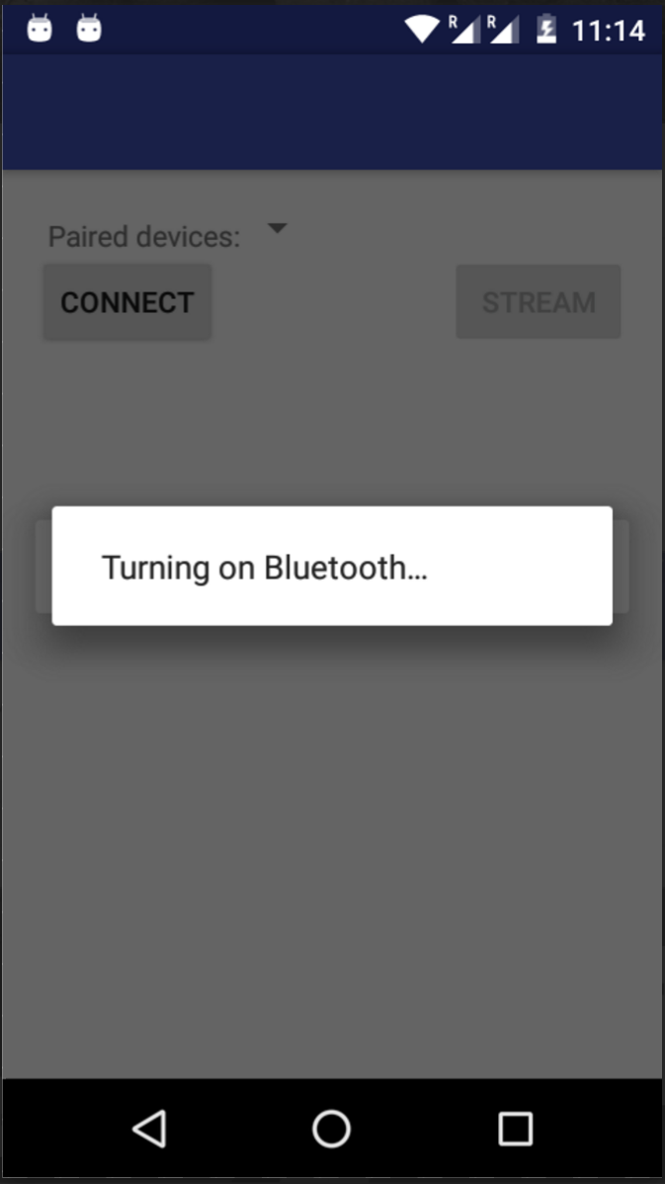

Pairing with other devices

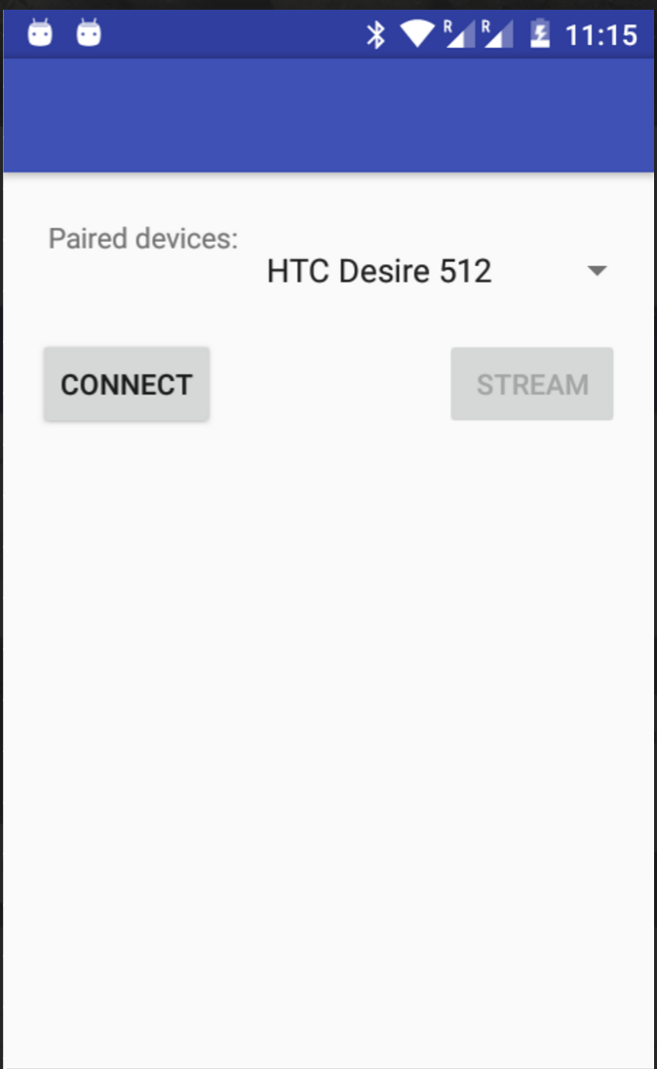

Streaming File

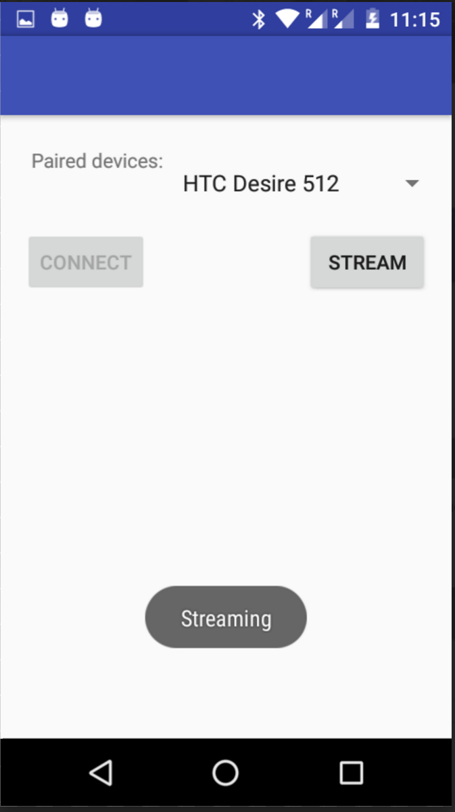

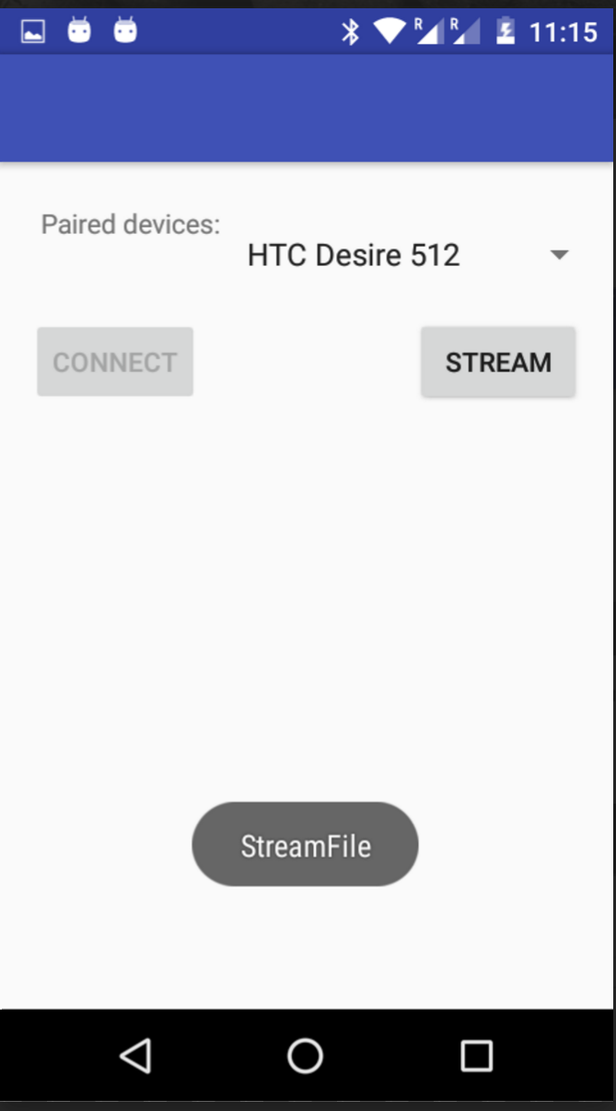

# 8. Appendices

<http://www.codeproject.com/Articles/814814/Android-Connectivity>

<http://guid-convert.appspot.com/>

<http://javapapers.com/android/android-sqlite-database/>

<http://www.androidhive.info/2011/11/android-sqlite-database-tutorial/>